SECTION 504 HANDBOOK

MEVSD Office of Student Services
1000 Edgewood Drive
Marysville, Ohio 43040
937-578-6141

TABLE OF CONTENTS
Page

I. SECTION 504 OVERVIEW

504 – Who Is Eligible? 1
Major Life Activities 1
“Substantially Limits” 1
Who Then? Who Might Be Considered? 1
Who Makes The Referrals? 1
Who Evaluates? Who Determines Eligibility? 2
Requirements for Evaluation 2
Tools for Evaluation 2
Eligibility Determination 2
Examples of Accommodations and Modifications 2
Reevaluation 2
Consent for Evaluation 3
Due Process – Student/Parent Rights 3
Ramifications – Testing 3
Ramifications – Discipline 3
Section 504 Administrative Guidelines for Identification, Evaluation,
and Placement of Students with Disabilities 4

II. SECTION 504/ADA GRIEVANCE PROCEDURE

Board Policy, Nondiscrimination on the Basis of Disability, ACB

III. SECTION 504 REFERRAL FLOW CHART

IV. APPENDIX

Frequently Asked Questions A-1
Discipline and Section 504 and the ADA A-3
Examples of Accommodations and Modifications A-4
More Accommodations A-5

V. FORMS

• 504-1 Section 504 Referral Form
• 504-2 Section 504 Parent Notification Letter (Meeting of the Team)
• 504-3 Invitation to Section 504 Team Meeting
• 504-4 Section 504 Evaluation Report
• 504-5 Section 504/ADA Student Accommodation Plan
• 504-6 Manifestation Determination Procedures for a Student with 504 Plan Subject to
Discipline
• 504-7 Manifestation Determination Review – 504 Plan Student
• 504-8 Section 504 Written Notice to Parents
• 504-9 Section 504 Plan Checklist

I. SECTION 504 OVERVIEW

Section 504 Overview

504 – Who Is Eligible?

 Any person that has a physical or mental impairment that substantially limits one or more of the person’s major life activities.

Major Life Activities

• The term “major life activities” includes, but is not limited to, several activities, including caring for one’s self, performing manual tasks, seeing, hearing, eating, sleeping, walking, standing, lifting, bending, speaking, breathing, learning, reading, concentrating, thinking, communicating and working. This is a non-exhaustive list.

• The term “major life activity” includes the operation of a major bodily function, including functions of the immune system, normal cell growth, and digestive, bowel, bladder, neurological, brain, respiratory, circulatory, endocrine and reproductive functions.

“Substantially Limits”

 Unable to perform a major life activity that the average person in the general population can perform.
 Must consider:
- nature and severity of impairment.
- duration or expected duration of impairment.
- permanent or long-term impact resulting from the impairment.

Who Then? Who Should Be Considered?

 Any student referred for IDEA but the decision is not to evaluate;
 Any student evaluated for IDEA but determined not to be eligible;
 Any student suspected of having any disability;
 Any student that continues to display behavior problems;
 Any student with a major health problem;
 When a parent requests consideration for 504 services;
 When a teacher requests consideration for 504 services.

Who Makes The Referrals?

 Generally, teachers and parents make most of the referrals.

Who Evaluates? Who Determines Eligibility?

 “A group of knowledgeable people.” Placement decisions should be made by a group of persons, including persons knowledgeable about the child, the meaning of the evaluation data, and the placement options. This team includes the child’s parent or guardian.

- At the Marysville Exempted Village Schools this team is the building Intervention Assistance Team and the parent or guardian.

Requirements for Evaluation

 Determine if a physical or mental impairment is present;
 Determine if the impairment results in a substantial limitation of one or more major life activities (not limited to learning or impact on educational performance);

Requirements for 504 Plan

 Determine the types of accommodations and placement required to enable the student to receive a free and appropriate education.

Tools for Evaluation

 In interpreting evaluation data and in making placement decisions, the evaluation team shall draw upon information from a variety of sources, including aptitude and achievement tests, teacher recommendations, physical condition, social or cultural background, and adaptive behavior.

 A variety of evaluation data must be used. (This data may include group standardized testing, screening tests for ability and achievement, work sample, record review, and observations.)

Eligibility Determination

 The team must determine “if there is a substantial limitation to one or more major life activities.”
 This is a team judgment decision.

Examples of Related Aids and Services If the Student is Determined to Have a Disability (which is not an exhaustive list)

 Seating arrangements
 Homework assignments
 Modifications in testing
 Readers or taped materials
 Grouping arrangements
 Adjusted class schedule
 Modified physical education program

Reevaluation

 Schools are only required to reevaluate students who are receiving 504/ADA services periodically (Schools may choose to follow the three-year reevaluation schedule used with IDEA); before a significant change of placement; or when conditions warrant.

Consent for Evaluation

 Obtain written parent consent prior to 504 evaluation.

Student/Parent Rights

 Informed of specific due process rights
 Equal academic/non-academic activities
 Appropriate education in least restrictive environment
 Notice re: referral, evaluation, and placement
 Fair evaluation
 Administrative appeals process
 Examine/obtain copies of all relevant school records

Ramifications – Testing

 Section 504 requires that students with a 504 plan must be provided with appropriate test accommodations, where necessary.
 The team will determine appropriate test accommodations which will be incorporated in the Section 504 plan.
 Section 504 plans may, as necessary, for individual students include testing accommodations for the district and statewide assessments.
 A student with a 504 plan will receive only the testing accommodations specified in the 504 plan for the district and statewide assessments.

Ramifications – Discipline

 Students served under Section 504 and the ADA are treated similar to students served under IDEA with regard to discipline.
- notice of charges, formal hearings
- a disciplinary removal of more than ten days is considered a significant change of placement requiring a manifestation determination to determine if the behavior is related to the student’s disability.
- A series of suspensions that are each of ten days or fewer in duration that creates a pattern of exclusions may also constitute a “significant change in placement.” The determination of whether a series of suspensions creates a pattern is made on a case-by-case basis. In no case, however, may serial, short exclusions be used to avoid the requirement of a manifestation determination before suspensions of more than ten days.
- Among the factors considered in determining whether a series of suspensions has resulted in a “significant change in placement” are the length of each suspension, the proximity of the suspensions to one another, and the total amount of time the child is excluded from school.
- A series of suspensions that, in the aggregate, are for ten days or fewer are not a significant change in placement.

SECTION 504 ADMINISTRATIVE GUIDELINES FOR
IDENTIFICATION, EVALUATION, AND PLACEMENT
OF STUDENTS WITH DISABILITIES

I. PROCEDURES FOR NEW SECTION 504 INQUIRIES – STUDENTS

A. REFERRAL – Requests for an evaluation of a student to determine eligibility for a 504 plan may be made by parents, teachers, or other knowledgeable professionals by a written referral. Referrals may be made at any time during the school year. Written referrals for an evaluation of a student will be filed with the Building Principal by using the Section 504 Referral form 504-1. The Form can be found in the District’s Section 504 Handbook or a form can be obtained from the Building Principal. Prior to completing the written referral, school staff are encouraged to contact the Building Principal to seek input and/or guidance regarding the need for referral.

Any staff member receiving a referral request from a parent, shall file the referral form with the Building Principal. Verbal requests by a parent for an evaluation shall be documented by the staff member receiving the verbal request by using the Section 504 Referral Form 504-1 to document the request for the evaluation. Other than for parental requests for an evaluation, school staff are encouraged to contact the Building Principal to seek input and/or guidance regarding the need for referral prior to completing the written referral form 504-1. Referrals may be made at any time during the school year.

B. Team Meeting – A Team Meeting will be scheduled to discuss needed information. The individuals that could be involved are: Parents, Student, Building Principal, Guidance Counselor, School Medical Personnel, Teachers and School Psychologist.

C. ASSESSMENT – The Team will collect all relevant information on the student (i.e. medical reports, doctor reports, medication, grade cards/report cards, school history, disciplinary action, etc.) to assist in documenting the following:

1. Whether the student has a physical or mental impairment that:

2. Substantially limits one or more major life activities such as caring for one’s self, performing manual tasks, seeing, hearing, eating, sleeping, walking, standing, lifting, bending, speaking, breathing, learning, reading, concentrating, thinking, communicating and working. This list is not exhaustive.

Major life activity also includes the operation of a major bodily function, including functions of the immune system, normal cell growth, and digestive, bowel, bladder, neurological, brain, respiratory, circulatory, endocrine and reproductive functions. This list is not exhaustive.

Written parental consent shall be obtained for an evaluation and a copy of student and parental rights sent. An evaluation is then performed and the eligibility determination and the information upon which it was based should be carefully documented in writing.

Reevaluations. The team will review and plan for a reevaluation which must be done periodically (a minimum of every three years), prior to a significant change of placement or if conditions warrant. Transferring a student from one type of program to another or terminating or significantly reducing a related service is a significant change in placement. For disciplinary changes in placement, see page 3 in Section 504 Overview. When a reevaluation is needed, written parental consent shall be obtained and a copy of student and parental rights provided to the parent.

D. Eligibility Determination: Following completion of the assessment/evaluation, the 504 Coordinator will schedule a Team meeting to review the information, determine eligibility, and determine how to proceed.

Information to be considered by the team should include: individual or group achievement tests, student work samples, observations, behavior checklists, teacher rating scales, teacher information, school records, medical information, and parent information.

E. Factors to be considered in determining whether a student’s physical or mental impairment substantially limits his/her learning.

The factors that should be considered by the Team in determining whether a student’s physical or mental impairment substantially limits his/her learning are as follows: (generally, multiple factors will be necessary to demonstrate substantial limitation)

1. Has the student demonstrated a consistent need for substantially more time to complete homework assignments than required by students without disabilities?

2. Has the student demonstrated a consistent need for substantially more time to complete in-school assignments than required by students without disabilities?

3. Is modified testing consistently necessary for the student to be able to demonstrate knowledge?

4. Does the student exhibit frequent behaviors, such as drowsiness, impulsivity, inattentiveness, or aggressiveness, associated with an identified physical or mental impairment or medication taken to address the condition and do these behaviors significantly interfere with school performance?

5. Does the student exhibit significant difficulty with planning, organization and execution of school-related activities and assignments?

6. Is the student chronically absent or tardy for reasons related to a diagnosed physical or mental impairment and are such absences or tardies interfering with his/her school performance?

7. Has the student experienced a steady decline in academic performance for which there is no known cause other than the diagnosed physical or mental impairment?

8. Has the student experienced a steady increase in disciplinary interventions for which there is no known cause other than the diagnosed condition?

9. After at least two intervention strategies have been implemented in regular education, does the student still exhibit significant learning difficulties?

(Please note that a student is not required to have a substantial limitation on learning to be eligible under Section 504. The Team must also consider whether the student has a physical or mental impairment that has a substantial limitation on one or more other major life activities as well as learning.)

F. Guidelines for medical documentation when a student is suspected of being disabled.

1. If the District determines, based on the facts and circumstances of the individual case, that a medical assessment is necessary to make an appropriate evaluation, the District must ensure the student receives this assessment at no cost to the parents. If alternative assessment methods meet the evaluation criteria, these methods may be used in lieu of a medical assessment.

2. The District may ask but not require a parent or a student to provide a medical statement if the District suspects the student has a disability that would result in eligibility for a 504 plan.

3. If the District does not believe the student has a disability that would result in Section 504 eligibility, then the District is not required to conduct an evaluation of the student. However, the District must provide the parents with written notice of the decision not to evaluation the student and the Section 504 Parent Information Brochure which includes the Notice of Parent and Student Rights.

G. Possible outcomes of the meeting:

1. Student determined to be eligible for free appropriate public education pursuant to a Section 504 Plan;

2. Student determined to be ineligible as a student with a disability under Section 504 to receive services pursuant to a Section 504 Plan but does need some interventions that can be developed by the Team;

3. The Team determines that it needs to collect more information before making an eligibility determination (Parents, Doctors, Observations, MFE, etc.); or

4. Student determined ineligible as a student with a disability under Section 504 to receive services pursuant to a Section 504 Plan and has no need for special school/classroom interventions. Student will be served appropriately in the regular education program without specific interventions. The record of the District’s proceedings should reflect the identification of the student as not disabled under Section 504, and state the basis for the decision that no special services/accommodations are presently needed.

H. If a Section 504 Plan is determined to be appropriate, a Team meeting will be scheduled to develop and complete the Section 504 Plan Form. The parents will be invited to the meeting to provide input. As an option to attendance at a meeting, the parents can participate in a meeting by telephone conference. If the parents are not able to participate in the meeting, the District will attempt other means to obtain parental input before finalizing a placement decision. Aside from the description of the student’s disability or related services needed, the Plan should also specify how the regular education and related aids and services, will be provided, and by whom. The Section 504 plan, when applicable, will specify the amount of services to be provided. The Section 504 Plan should include parent/team signatures. A copy of the Plan should also be placed in the student’s cumulative folder. If the parents are not present at the meeting or participate by telephone conference, a copy of the 504 plan will be sent to the parents requesting that they give written input to the plan. The parents will also be asked to give written consent to the plan if there are no revisions they want to make to the plan. One way of the parents give written consent is by signing the plan. The parents will be provided with a copy of the Section 504 Parent Information Brochure which includes the Parent and Student Rights.

The initial 504 plan cannot be implemented without parental consent. Subsequent 504 plans can be implemented without parent consent if there is not a significant change of placement. A copy of the 504 Plan and the Section 504 Parent Information Brochure which includes the Parent and Student Rights must be provided to the student’s parents each time a 504 plan is developed.

I. Upon completion of the Section 504 Plan, the Team needs to follow Procedures for Existing Section 504 Plans – Students (see Section II).

J. If the parents want to challenge the actions regarding identification, evaluation or placement of their child, the Board must provide a due process hearing before an impartial hearing officer to resolve the dispute. Information about due process procedures will be provided to the parents by the 504 Coordinator or the Building Principal.

K. The provisions regarding parents also apply to guardians whenever a student has a guardian acting on their behalf.

II. PROCEDURES FOR EXISTING SECTION 504 PLANS – STUDENTS

A. Annual review.

1. At the beginning of each school year (August – September), a list of students who have had Section 504 Plans in the past school year are given to the Building Principal. The requirements of a student’s 504 plan will be provided by the Building Principal to every teacher who has the student.

2. The 504 Team will review the Section 504 Plan on or before the annual review due date.

3. The student’s parents will be notified of the need to review the Section 504 Plan. The parents will be invited to a meeting of the 504 team.

4. The purpose of the meeting will be to formulate a Section 504 Plan for the student. Knowledgeable individuals included in the meeting may be as follows: Parents, Student, Building Principal, Guidance Counselor, School Medical Personnel, Teachers and 504 Coordinator.

The 504 Team should decide whether to: (1) continue the plan; (2) discontinue; or (3) write a new plan.

The 504 Team will review and plan for a reevaluation which must be done periodically (a minimum of every three years), prior to a significant change of placement or when conditions warrant. Discontinuing the plan or writing a new plan including a significant change of placement, will require a reevaluation.

5. The parents will be invited to the meeting to provide input. As an option to attendance at a meeting, the parents can also participate in a meeting by telephone conference. If the parents are not able to participate in the meeting, the District will attempt other means to obtain parent input. A copy of the plan will be sent to the parents. The parents will be asked to give written input to the plan. The parents will also be asked to consent to the plan if there are no revisions they want to make to the plan. A copy of the Section 504 Parent Information Brochure which includes the Parent and Student Rights will be sent along with the plan. If the parents do not give written consent to the plan, it can still be implemented unless there is a significant change of placement.

6. A copy of the Plan will be placed in the student’s cumulative record folder at the building level.
B. During the school year.

The Section 504 Plan can be reviewed by the team at any time if concerns develop as to the appropriateness of the modifications/accommodations being used with the student. This review can be initiated by staff or parents.

C. Procedural Safeguards.

Procedural safeguards for parents and students are contained in the Section 504 Parent Information Brochure.

The notice of procedural safeguards is to be provided to the parent with respect to actions regarding the identification, evaluation, or educational placement (including creation of a 504 plan) of students who, because of their disability, receive services under Section 504.

The procedural safeguards include notice, an opportunity for the parents or guardian of the student to examine relevant records, an impartial hearing with an opportunity for participation by the student’s parents or guardian and representation by counsel, and a review procedure.

Anytime the written results of a meeting are provided to the student’s parents, the notice of parent and student rights will be provided to the parents.

Provide a copy of the procedural safeguards to the parents at any team meeting.

D. If the parents challenge the actions of the District regarding identification, evaluation or placement of their child, the Board must provide a due process hearing before an impartial hearing officer to resolve the dispute. See Section 504 Grievance and Due Process Procedures.

E. The provisions regarding parents also apply to guardians whenever a student has a guardian acting on their behalf.

II. SECTION 504/ADA
GRIEVANCE PROCEDURE

NONDISCRIMINATION ON THE BASIS OF DISABILITY

Section I

The Board maintains that discrimination against a qualified disabled person solely on the basis of disability is unfair. To the extent possible, qualified disabled persons should be in the mainstream of life in a school community.

Accordingly, employees of the District will comply with the law and Board policy to ensure nondiscrimination on the basis of disability. The following are expected:

1. No one will discriminate against qualified disabled persons in any aspect of school employment solely on the basis of disability;

2. Facilities, programs and activities will be made available to qualified disabled persons;

3. Free appropriate education at elementary and secondary levels, including nonacademic and extracurricular services and activities will be provided to qualified disabled persons;

4. No one will exclude any qualified disabled person, solely on the basis of disability, from participation in any preschool, day care, adult or vocational education program; and

5. Each qualified disabled person will be provided with the same health, welfare and other social services as are provided to others.

The Superintendent or designee is the District’s 504 Coordinator. In the Marysville Exempted Village School District, the Director of Student Services is the District’s 504 Coordinator. The address of the District’s 504 Coordinator is 1000 Edgewood Drive, Marysville, OH 43040. The telephone number is 937-644-8105.

Section II

Grievance Procedures for Section 504 and ADA

This grievance procedure may be used for a complaint alleging a violation of Section 504 of the Rehabilitation Act of 1973 or the Americans with Disabilities Act. The same grievance procedure may be used for any other federal law requiring a grievance procedure. A copy of the District’s grievance procedure may be obtained from the District’s 504 Coordinator.

A person who believes s/he has a valid basis for a grievance may discuss the grievance informally and on a verbal basis with the District’s 504 Coordinator, who shall in turn investigate the complaint and reply with an answer to the complaint. S/He may initiate formal procedures according to the following steps:

Step 1— District’s 504 Coordinator’s Investigation. A person who believes he/she has a valid basis for a grievance may initiate a grievance by completing the Section 504/ADA Grievance filing form and providing it to the District’s 504 Coordinator. The request shall fully describe the grievance, citing the specific circumstances or areas of dispute which have resulted in the complaint, and be filed as soon as possible, but not longer than thirty (30) calendar days after disclosure of the facts giving rise to the grievance. The District’s 504 Coordinator shall conduct an investigation which includes a meeting with the person filing the grievance within five (5) school days following receipt of the request. At the meeting, the person filing the grievance may present witnesses and other evidence concerning the grievance. The District’s 504 Coordinator will state in writing his/her decision to the individual within five (5) school days following the conference.

If the 504 Coordinator determines that discrimination has occurred, the School District will take reasonable, timely, age appropriate, and effective corrective action, including steps tailored to the specific situation.

If the grievance is filed against the 504 Coordinator, the grievance shall be investigated by the Superintendent or designee.

Step 2 – Appeal to the Superintendent. If the grievance is not resolved satisfactorily at Step 1, the District’s 504 Coordinator’s decision may be appealed in writing to the Superintendent. (If the Superintendent is the District’s 504 Coordinator, Step 2 will be skipped. The Appeal is to Step 3.) The appeal must be made within ten (10) school days following the receipt of the District’s 504 Coordinator’s decision. The Superintendent will review the case, may conduct an informal hearing, and will notify all parties in writing of his/her decision within ten (10) school days of receiving the appeal.

Step 3 – Appeal to the Board of Education. If the grievance is not satisfactorily resolved through Step 2, a written appeal may be made to the Board of Education. The grievance must be filed with the Superintendent’s Office within five (5) school days of the Superintendent’s written decision at Step 2.

The Board or its designee will conduct a hearing regarding the alleged grievance within thirty (30) school days of filing of the appeal. The parties can agree to extend the time for the hearing. The Board or designee shall give the complaint a full and fair opportunity to present evidence relevant to the issues raised by the grievance. The complainant may, at his/her own expense, be assisted or represented by individuals of their choice, including legal counsel. The Board or designee will make a written decision to the District’s 504 Coordinator and complainant within ten (10) school days of the hearing.

The person wishing to file a grievance may also file a complaint at any time with the U.S. Department of Education, Office for Civil Rights, 600 Superior Avenue East, Suite 750, Cleveland, OH 44114-2611.

Section III

Due Process Hearing Procedure

1. When a request for a due process hearing is received, the aggrieved party will have the opportunity to receive a hearing conducted by an impartial hearing officer (“IHO”) (i.e. by a person not employed by the board of education, not involved in the education or care of the child, and not having a personal or professional interest which would conflict with his/her objectivity in the hearing).

2. The parties can agree to refer the due process issue to mediation. The mediator may be selected from the list of mediators at the Office for Exceptional Children, Ohio Department of Education.

3. The School District will maintain a list of IHOs, which may include IDEA hearing officers, attorneys, and Directors of Special Education outside the District. The District’s 504 Coordinator will appoint an IHO from that list, and the costs of the hearing shall be borne by the School District. The appointment of an IHO will be made within fifteen (15) school days after the request for a due process hearing is received.

4. A party to a due process hearing shall have:

a. The right to be accompanied and advised by counsel and by individuals with special knowledge or training with respect to the problems of children with disabilities;

b. The right to present evidence, confront, and cross-examine witnesses;

c. The right to a written or electronic verbatim record of such hearing; and

d. The right to written findings of fact and decisions.

5. The IHO shall conduct the due process hearing within a reasonable period of time (i.e. not to exceed ninety (90) days of the request for such a hearing, unless this time-frame is mutually waived by the parties or is determined by the IHO to be impossible to comply with due to extenuating circumstances).

6. The IHO will give the parent and/or student written notice of the date, time and place of the hearing. Notice will be given no less than twenty-one (21) days prior to the date of the hearing, unless otherwise agreed to by the parties.

7. The person filing the grievance may be represented by another person of his/her choice, including an attorney.

8. The IHO shall make a full and complete record of the proceedings.

9. The IHO shall render a decision in writing to the parties within thirty (30) days following the conclusion of the hearing. The decision will include findings of fact.

10. Either party shall have a right to appeal the decision of the IHO upon filing a written request for an appeal within fifteen (15) days of the date of the IHO’s written decision. The appeal request must be timely filed with the District’s 504 Coordinator.

11. In the request for an appeal, the requesting party shall specifically set forth the reasons the party feels the decision of the IHO is either contrary to and not supported by the evidence, or is otherwise contrary to law.

12. The appeal shall be heard by another IHO, who shall be appointed by the District’s 504 Coordinator.

[Adoption date: July 31, 1995]
[Re-adoption date: April 26, 2004]
[Re-adoption date: March 21, 2013]

LEGAL REFS.: Individuals with Disabilities Education Act; 20 USC 1400 et seq.
Rehabilitation Act of 1973; 29 USC 794
Americans with Disabilities Act; 42 USC 12112 et seq.
ORC 3323.01 et seq.
Chapter 4112

CROSS REFS.: AC, Nondiscrimination
ACA, Nondiscrimination on the Basis of Sex
AE, School District Goals and Objectives
GBA, Equal Opportunity Employment
IGBA, Programs for Students with Disabilities
IGDJ, Interscholastic Athletics
JB, Equal Educational Opportunities
JFCF, Hazing
Staff Handbooks
Student Handbooks

A copy of the 504/ADA Grievance Filing Form is attached

Marysville Exempted Village School District
Section 504/ADA Grievance Filing Form

Date _______________

Name

School

Place where you may be reached

Address

Phone

Nature of your grievance. (Please describe the policy or action you believe may violate Section 504/ADA or otherwise constitutes discrimination based on disability.)

Name of whom has been affected by the discrimination

Name and address of the discriminating agency

The approximate date of the discriminatory conduct

A brief description of what happened

Please describe any corrective action you wish to see taken with regard to the possible violation. You may also provide other information relevant to this grievance.

____________________________ _______________________________
Signature of Grievant School Official

____________________________ ____________________________ ____________
Date of Grievant’s Signature Date 504 Coordinator Received Time

This form is to be filed with the 504 Coordinator, the Director of Student Services, 1000 Edgewood Drive, Marysville, OH 43040.

III. Section 504 Referral Flow Chart

The Team, teacher, counselor,
parent, principal, etc. initiates Section 504 Referral.

The Team reviews case, schedules
multi-source evaluation and data collection procedures.

The Team meets, reviews data from multi-source evaluation.
(Parents are notified of decisions and Section 504 procedural safeguards.)

Not eligible as Section 504  student. No service. | Eligible as Section 504  student. | Referral for Special  Education Evaluation.

• The Team brainstorms accommodations.
• Clarifies and specifies accommodations.
• Sets implementation timelines.
• Identifies person(s) responsible for implementing, monitoring, and supporting
accommodations.
• Parents are notified of decisions and Section 504 procedural safeguards.

Periodically review progress.

IV. APPENDIX

Frequently Asked Questions

What are the guidelines or criteria that determine if a child qualifies for 504/ADA?

A group of knowledgeable individuals in the school makes a determination whether or not a physical or mental impairment results in a substantial limitation of one or more major life activities.

Does an evaluation of no exceptionality automatically qualify a student for 504/ADA?

No. In order to be eligible for Section 504/ADA services, a student must have a physical or mental impairment. A student does not have to have a clinical label in order to be eligible for services.

Does a child qualify for 504/ADA while being evaluated or before being evaluated for IDEA?

Not unless the child has a physical or mental impairment that results in a substantial limitation of a major life activity. Being referred for IDEA services is not linked to eligibility under 504/ADA.

Should a 504/ADA plan be written on a student who is referred for an IDEA evaluation at the time of referral?

No. If after an evaluation under IDEA, the student is determined not eligible for special education, the student may still be eligible for a 504 plan if the student meets the conditions under which a 504 plan should be written.

When does a student qualify for 504 due to behavioral problems?

When a group of knowledgeable persons determines that the behavior is a result of a physical or mental impairment and a major life activity has been substantially limited.

Can a 504/ADA student be expelled/suspended?

Yes, if a manifestation determination indicates that the disability is not related to the behavior and the behavior results in expulsion or suspension for other students.

A disciplinary removal of more than ten days is considered a significant change of placement requiring a manifestation determination.

A series of suspensions that are each of ten days or fewer in duration that creates a pattern of exclusions may also constitute a “significant change in placement.” The determination of whether a series of suspensions creates a pattern is made on a case-by-case basis. In no case, however, may serial, short exclusions be used to avoid the requirement of a manifestation determination before suspensions of more than ten days.

Among the factors considered in determining whether a series of suspensions has resulted in a “significant change in placement” are the length of each suspension, the proximity of the suspensions to one another, and the total amount of time the child is excluded from school.

A series of suspensions that, in the aggregate, are for ten days or fewer are not a significant change in placement.

What safeguards/rights are related to expulsion/suspension?

A manifestation determination must be made. If the determination is that the behavior is related to the disability, then the student may not be expelled or suspended for more than ten days. If it is determined that the child’s misconduct is caused by the child’s disability, the team must determine whether the child’s current 504 plan and educational placement is appropriate.

If there is no relationship, the student can be disciplined like other students.

Do educational services have to be provided to a student with a 504 plan who is expelled or suspended because there is no relationship between the behavior and disability?

No, if a manifestation determination indicates that the disability is not related to the behavior and the student is then either expelled or suspended, educational services do not have to be provided to the student during the time of expulsion or suspension.

Should there be written documentation that a parent has been invited to a meeting?

Yes. Parents must be notified about procedures under 504 and the ADA and documentation should be kept verifying such notification.

Is there any recourse for a child with ADD/ADHD who is on medication, but is not taking it at home? Is the 504 plan still in effect?

Schools cannot dictate whether or not students take medication. This is strictly a parent decision. Schools must deal with the child however he presents himself – with or without the medication.

What are suggested accommodations for assistance with behavior in general classrooms for 504 students with behavior disorders?

Some possible accommodations to address behaviors include a behavior intervention plan, seating arrangement, positive reinforcements, and individual behavioral contract. A student’s Section 504 plan must be individually tailored to address the student’s needs. It is possible that a student on a 504 plan could be evaluated and placed on an IEP if the team determines it is necessary for a free appropriate public education.

Whose responsibility is it to notify the school of a diagnosis when a student has been to a doctor or mental health facility?

The parents. Medical information is confidential and can only be shared with parental consent. However, the school is obligated to evaluate a student with a suspected disability. The school cannot require parents to provide medical information. If the school needs written information to complete an evaluation of a student with a suspected disability then it is the school’s responsibility to provide that assessment.

Can students with consistent behavior problems (suspensions/past expulsions) qualify for 504 without an official diagnosis?

Yes. If the team determines that a physical or mental impairment exists that substantially limits a major life activity, then the team may make the determination that the child is eligible. No specific clinical label is required.

If a parent disagrees with the decision of the 504/ADA committee, what should be the next step?

The parent must be informed of his/her due process rights. The decision to appeal the decision is the parent’s.

Should a student who is gifted/talented, with behavior problems, have a 504 plan?

A child who is gifted/talented is not precluded from placement on a 504 plan, if that child has a physical or mental impairment that substantially limits one or more major life activities.

Does a student have to be on medication if they are 504/ADD/ADHD?

No. To medicate or not is the parent’s decision.

Can a student be identified as both a disabled student and a Section 504 and under the IDEA and have both a Section 504 Plan and an IEP?

No. The student would have either an IEP or a Section 504 Plan based upon an evaluation under IDEA and/or Section 504. (See Section III-504 Referral Flow Chart)
Discipline and Section 504 and the ADA

Students having a Section 504 Plan are treated similar to students having an IEP with regard to discipline. First, these students can definitely be disciplined. Rules and standards can be applied to these students just as they are applied to nondisabled students. The important thing to consider is that these students have an equal opportunity to be successful with classroom rules and behavioral regulations. In order to ensure this with some students, a behavior intervention plan may be necessary to have in place.

Before taking certain actions with students with a 504 Plan, school personnel must follow specific steps. The following summarizes some of the considerations when dealing with students with a 504 Plan:

● Disciplinary procedures for students under 504 are similar to those under IDEA.

● Under IDEA, 504, and the ADA, additional procedures may apply in addition to the usual procedures provided to regular education students subject to discipline.

● A removal of more than ten days is considered a significant change of placement and requires procedural requirements of 504.

● A manifestation determination must be made before suspending or expelling a student with a 504 Plan for more than ten days.

● Suspensions resulting in a total of ten or less days in a school year are permissible. A series of suspensions that are each of ten days or fewer in duration that creates a pattern of exclusions may also constitute a “significant change of placement.” The determination of whether a series of suspensions creates a pattern is made on a case-by-case basis. In no case, however, may serial, short exclusions be used to avoid the requirement of a manifestation determination before suspensions of more than ten days. Among the factors considered in determining whether a series of suspensions has resulted in a “significant change of placement” are the length of each suspension, the proximity of the suspensions to one another, and the total amount of time that the child is excluded from school. A series of suspensions that, in the aggregate, are for ten days or fewer are not a significant change of placement.

● If a manifestation determination shows no relationship between the behavior and disability, then the student may be disciplined as any other student.

● If a manifestation determination shows that there is a relationship between the behavior and disability, then the student may NOT be expelled or suspended; the school should consider the appropriateness of the current program and consider appropriate changes.

● Students with a 504 Plan do not have to be provided with educational services during an expulsion or suspension for behavior not related to the disability.

● Students currently engaged in drug or alcohol abuse are not protected under Section 504.

● The manifestation determination review is conducted by the members of the student’s 504 school team and the parent.

Examples of Accommodations and Modifications

In order for schools to provide an appropriate education for students who are protected under Section 504 and the ADA, accommodations and modifications will likely be necessary. These may be implemented in special education classrooms or general education classes. The vast majority of accommodations and modifications for students served under 504 and the ADA will occur in general education classrooms. Any student must be provided a free appropriate public education. There are numerous accommodations and modifications that schools can include in students’ educational plans. The following are examples of these accommodations and modifications:

● A student with a long term, debilitating medical problem such as cancer, kidney disease, or diabetes may be given special consideration to accommodate the student’s needs. For example, a student with cancer may need a class schedule that allows for rest and recuperation following chemotherapy.

● A student with a learning disability that affects the ability to demonstrate knowledge on a standardized test or in certain testing situations may require modified test arrangements, such as oral testing or different testing formats.

● A student with a learning disability or impaired vision that affects the ability to take notes in class may need a note taker or tape recorder.

● A student with a chronic medical problem such as kidney or liver disease may have difficulty in walking distances or climbing stairs. Under Section 504, this student may require handicapped parking, sufficient time between classes, or other considerations, to conserve the student’s energy for academic pursuits.

● A student with diabetes, which adversely affects the body’s ability to manufacture insulin, may need a class schedule that will accommodate the student’s special needs.

● An emotionally or mentally ill student may need an adjusted class schedule to allow time for regular counseling or therapy.

● A student with epilepsy who has no control over seizures, and whose seizures are stimulated by stress or tension, may need accommodations for such stressful activity as lengthy academic testing or competitive endeavors in physical education.

● A student with arthritis may have persistent pain, tenderness or swelling in one or more joints. A student experiencing arthritic pain may require a modified physical education program.

Examples of Services/Aids/Accommodations
(This list is not exhaustive.)

Classroom Accommodations

□ Special toilet accommodations
□ Classes on first floor of building
□ Seated near chalk board
□ Seated near teacher’s desk
□ Seated near teacher aide’s desk
□ Seated away from other students
□ Provided daily schedule of activities
□ Allowed to leave before bell rings
□ Seated in study carrel
□ Utilize writing aids from OT
□ Provided additional set of books
□ Provided tape recorder
□ Provided with note taker
□ Provided with copy of lecture notes
□ Provided with necessary note-taking materials
□ Provided with written lists of information, directions
□ Moved closer to what is being viewed
□ Located in a room with minimized distractions
□ Assigned to another school
□
□
□

Administrative Accommodations

□ Assigned to another school
□ Referred to vocational rehabilitation
□ Provide each teacher a copy of accommodation plan
□ Reassign to a male teacher
□ Reassign to a female teacher
□ Allowed to leave school before end of day
□ Allowed to leave class early training for teachers in learning styles
□ Monthly meeting for student’s teachers
□ Variance from attendance policy
□ Air purifier in classroom
□ Provide special temperature control equipment
□ Health plan for student
□ Special parking
□ Assigned to a guidance counselor
□
Academic Accommodations

□ Daily posted schedule for student
□ Student will repeat phrases, directions
□ Extra time for assignments
□ Assignments on larger lined paper
□ Information presented in smaller chunks
□ More drill and practice activities
□ Participation in cooperative learning groups
□ Allowed to complete work late
□ Provided with lecture notes
□ Provided with large print materials
□ Handouts in large print
□ Instructions for outlining key ideas
□ Instruction in learning strategies
□ Allowed taped texts
□ Visual instruction (overheads, etc.)
□ Repeated or paraphrased instructions
□ Instructions on test-taking
□ Assigned a caseworker
□ Reminder about listening
□ Information presented loudly
□ Homework assignment notebook will be used
□ Allowed to ask questions
□
□
□

Social Accommodations

□ Role playing activities
□ Periodic rewards for positive behavior
□ Participation in development of behavior management plan
□ Behavior checklists used for evaluation
□ Participate in group counseling
□ Peer counselors and tutors
□ Use of time out when needed
□ Attempt work independently before assistance provided
□

Testing Accommodations

□ Tested with curriculum based assessment
□ Small group testing
□ Oral testing (student may answer orally)
□ Reader during testing
□ Tests in large print
□ Oral review of test material
□ Open-book tests
□ Reduced length of tests
□ Individually tested
□ Test printed in black, large letters
□ Provided with scribe
□ May use word processor to answer written responses
□
□

Special Considerations:
_____ monitoring student closely on field trip
_____ inservicing teacher(s) on child’s disability
_____ developing intervention strategies for transitional periods (e.g., cafeteria, physical education, etc.)
_____ alerting bus driver
_____ Other: __________________________________

Behavior Accommodations

□ Needs a contract to control behavior (individualized behavior plan)
□ Needs a second chance due to inconsistent performance (despite student effort)
□ Needs help and reassurance to handle moods and frustration
□ Do not ask student to read orally in class (unless volunteers)
□ Pair with a good role model
□ Amend the usual consequences for misbehavior (which doesn’t harm others)
□ Focus on social process rather than activity/end product
□ Use cooperative learning
□ Needs to receive concrete reinforcement (e.g. stickers, crackers, earning parent-provided toy, recess time, etc. where age appropriate)
□ Needs a cooling-off place away from class
□ Use behavior check cards

Behaviors:

_____ praising specific behaviors
_____ using self-monitoring strategies
_____ giving extra privileges and rewards
_____ keeping classroom rules simple and clear
_____ making “prudent use” of negative consequences
_____ allowing for short breaks between assignments
_____ cueing student to stay on task (nonverbal signal)
_____ marking student’s correct answers, not his mistakes
_____ implementing a classroom behavior management system
_____ allowing student time out of seat to run errands, etc.
_____ ignoring inappropriate behaviors not drastically outside classroom limits
_____ allowing legitimate movement
_____ contracting with the student
_____ increasing immediacy of rewards
_____ implementing time-out procedures

Additional Accommodations

V. FORMS

Marysville Exempted Village Schools
Section 504 Referral Form & Parent Consent

Student’s Name: Date of Referral:

Date of Birth: Age: Grade/Class:

School: Teacher:

Parent(s) Name:

Address: Telephone:

Reason(s) for Referral:

Pre-Referral Actions (Interventions), if any, to Address Concerns:

Person Making Referral:

Section 504 Consent to Evaluate

To: Parent(s)/Guardians:

Your child has been referred for a 504 evaluation for a suspected disability due to the above concerns. We need your permission to determine eligibility for services.

Should you give consent for an evaluation, the purpose is to determine whether your child has a physical or mental impairment that substantially limits one or more major life activities and which as a result may require your child to receive services with a 504 plan to ensure a free appropriate public education. You will be given an opportunity to provide information for your child’s evaluation.

After the evaluation is completed, another meeting with you will be scheduled to review the information collected during the evaluation and determine eligibility of your child for a 504 plan.

I CONSENT to the evaluation I DO NOT CONSENT to the evaluation

_____________________________ ______________________________________
Parent/Guardian Signature Date

The Section 504 Parent Information Brochure which includes the procedural safeguards for parent and student was given to the parent(s) at the Team meeting.

Yes No If No, date sent to parent(s):
Marysville Exempted Village Schools
Invitation to Section 504 Team Meeting

Date of Notice: ____________

Child: ___________________________

Dear Parent(s)/Guardian(s) and School Staff:

A Team meeting will be held for the above-named student. The purpose of this letter is to invite you to attend.

The meeting is scheduled for ______________________________________ at __________________________ at
(Date) (Time)

_____________________________________________________________ .
(Location)

School District staff should bring student work samples or other information documenting the child’s present levels of performance in your areas of responsibility.

Building Principal/Designee_________________________________________Date_________________________________

Parent’s Response to Notice of 504 Team Meeting

COMPLETE AND RETURN TO THE CHILD’S SCHOOL

I WILL attend I WILL NOT attend

I want to participate in the meeting by conference call. Please contact me at the time of the
scheduled meeting at this telephone number .

I want to come, but I cannot attend the meeting at the scheduled time.
I am available
Date(s) ________________________Time(s)______________________

____________________________________ ___________________
Parent/Guardian Signature Date

Marysville Exempted Village Schools
Section 504 Evaluation Report

Date___________________________

Evaluation Type (check one): □ Initial OR □ Reevaluation (Date of initial _______________)

Demographics
Student Name: _______________________ DOB: ______ Gender: ________ Grade:____________

Parent:_________________________ Phone Number:__________________ E-Mail Address:________________________

Area(s) of Concern/Physical or Mental Impairment:

Intervention(s) in Place:

Findings/Evaluation Results Summary (Attach relevant documentation.)

Medical Information:

Attendance Data (Attendance Patterns, Schools Attended):

Report Card/Transcript Information (Current Grades, Past Grades, Retentions):

Discipline Record/Behavior History:

Group Tests Results:

Teacher Information:

Parent Information:

Rating Scale Information:

Observation Data (Study Skills, Effort Ratings, Work Habits):

(continue)
Work Sample Data/Other:

Factors to be considered in determining whether an impairment substantially limits learning are included at end of this Section 504 Evaluation Report which applies only if the major life activity is learning.

Eligibility Criteria and Determination

□ Yes □ No Student has a mental or physical impairment

□ Yes □ No Student’s impairment substantially limits the following major life activity/activities:

□ Caring for oneself □ Caring for oneself □ Seeing □ Hearing
□ Eating □ Sleeping □ Walking □ Standing
□ Lifting □ Bending □ Speaking □ Breathing
□ Learning □ Reading □ Concentrating □ Thinking
□ Communicating □ Working
□ Operation of a major bodily function, including functions of the immune system, normal cell growth, digestive, bowel, bladder, neurological, brain, respiratory, circulatory, endocrine, and reproductive functions

□ Other

Consideration Factors in determining whether an impairment substantially limits learning

□ Yes □ No Has the student demonstrated a consistent need for substantially more time to complete homework assignments than required by students without disabilities?

□ Yes □ No Has the student demonstrated a consistent need for substantially more time to complete in-school assignments than required by students without disabilities?

□ Yes □ No Is modified testing consistently necessary for the student to be able to demonstrate knowledge?

□ Yes □ No Does the student exhibit frequent behaviors, such as drowsiness, impulsivity, inattentiveness, or aggressiveness, associated with an identified physical or mental impairment or medication taken to address the condition and do these behaviors significantly interfere with school performance?

□ Yes □ No Does the student exhibit significant difficulty with planning, organization, and execution of school-related activities and assignments?

□ Yes □ No Is the student chronically absent or tardy for reasons related to a diagnosed physical or mental impairment and are such absences or tardies interfering with his/her school performance?

□ Yes □ No Has the student experienced a steady decline in academic performance for which there is no known cause other than the diagnosed physical or mental impairment?

□ Yes □ No Has the student experienced a steady increase in disciplinary interventions for which there is no known cause other than the diagnosed condition?

□ Yes □ No After at least two intervention strategies have been implemented in regular education, does the student still exhibit significant learning difficulties?

□ Yes □ No Student meets 504 eligibility criteria, i.e., the team has checked “yes” to both of the above boxes.

(continue)

Rationale for Determination/Recommendations: (check the one that applies)

- It has been determined that ______________’s disability does significantly impact one or more of the major life activities identified above, which justifies eligibility for a 504 Plan.

- It has been determined that ______________’s disability does NOT significantly impact one or more of the major life activities identified above, which justifies ineligibility for a 504 Plan.

- Other: ___________________________________________________________________________________________________________________________________________________________________________

Projected 3 year Re-Evaluation Date:
(Transfer this date to the 504 Plan-front page)

Evaluation Team Members

Name | Title | Agreement
_______________________________ | _________________________ | □ Agree | □ Disagree
_______________________________ | _________________________ | □ Agree | □ Disagree
_______________________________ | _________________________ | □ Agree | □ Disagree
_______________________________ | _________________________ | □ Agree | □ Disagree
_______________________________ | _________________________ | □ Agree | □ Disagree

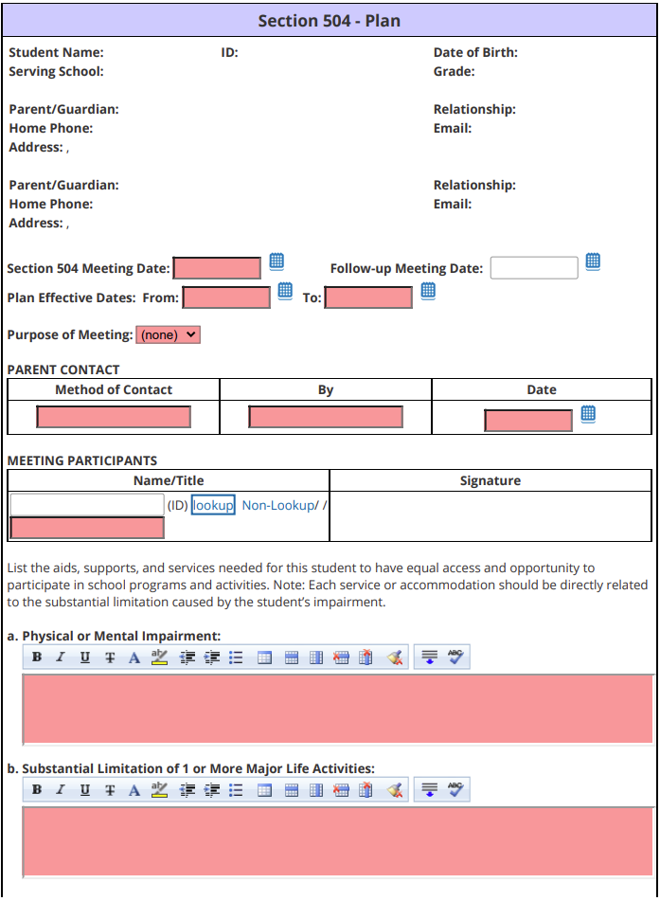
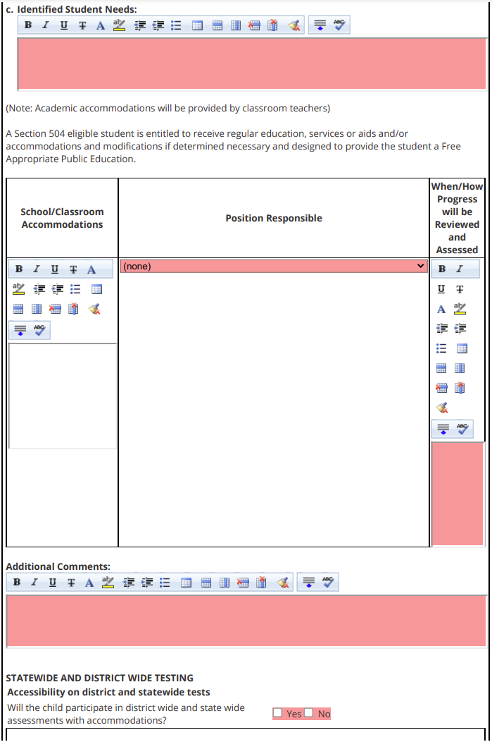
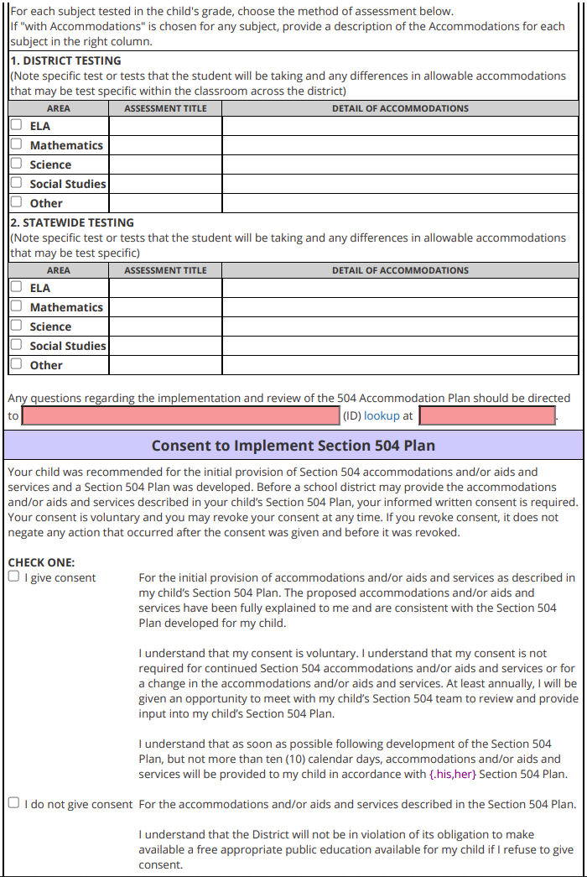
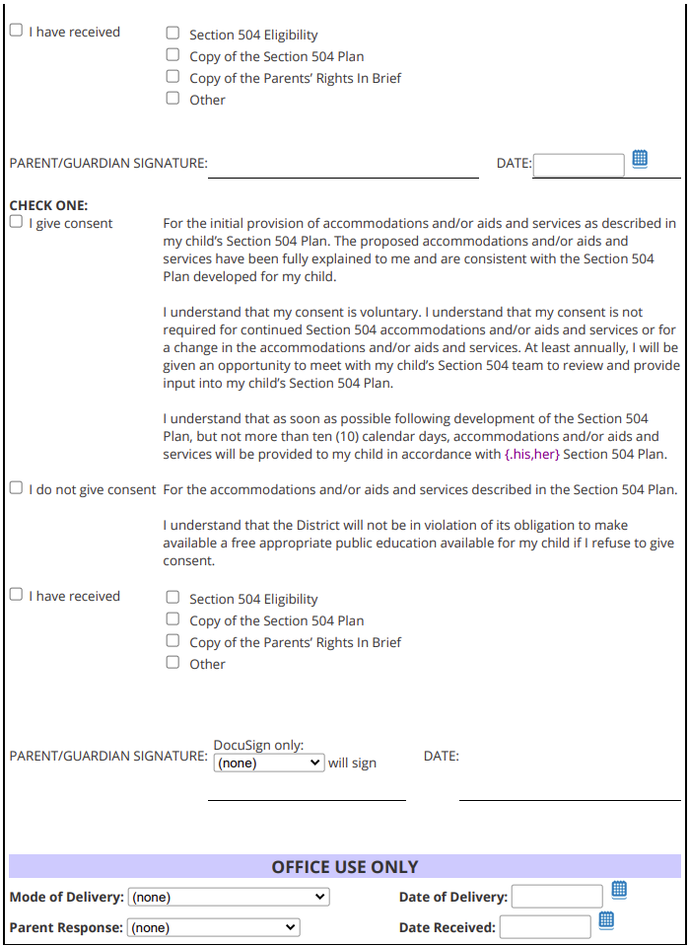

“Disabled person” means any person who has a physical or mental impairment which substantially limits one or more major life activities, has a record of such an impairment. The term “major life activities” includes several activities, including caring for one’s self, performing manual tasks, seeing, hearing, eating, sleeping, walking, standing, lifting, bending, speaking, breathing, learning, reading, concentrating, thinking, communicating and working.

The term “major life activity” includes the operation of a major bodily function, including functions of the immune system, normal cell growth, and digestive, bowel, bladder, neurological, brain, respiratory, circulatory, endocrine and reproductive functions.

WHO QUALIFIES UNDER
SECTION 504?

Students having the following disabilities may qualify for educational accommodations under Section 504: students afflicted with HIV, hepatitis, kidney disease, asthma, allergies, emotional disorders, drug addiction, accident victims, anorexics, and ADD/ADHD. This list is not exhaustive.

None of the above mentioned diseases or conditions, in and of themselves, qualify a student a student as disabled under Section 504. The conditions must be shown to substantially limit one or more major life activities to qualify the student as disabled under Section 504.

REFERRAL PROCEDURES AND EVALUATION

A parent, teacher, administrator or any other party interested in the student’s education may refer the student to be evaluated to determine the need for accommodations. A referral is made by contacting the school principal. If the student is suspected to have a physical or mental impairment which substantially limits one or more major life activities, he/she is referred for a 504 evaluation.

The evaluation will draw upon information from a variety of sources, which may include, but not be limited to, aptitude and achievement tests, teacher recommendations, reports on the student’s physical condition, social or cultural background, and adaptive behavior.
The eligibility determination for Section 504 is made by the parents and school staff who are knowledgeable regarding the student, evaluation data and placement options. If the student is found eligible, a 504 plan is written involving teachers, parents and, when appropriate, the student. The school members of the team are responsible for implementing and monitoring the 504 plan for the student. If the team determines that the student does not meet eligibility criteria under Section 504 because the disability does not substantially limit one or more major life activities, no services are developed under a 504 plan.

The team shall conduct a periodic reevaluation of students identified as disabled under Section 504. If the team determines the student continues to qualify under Section 504, a new plan will be developed.

CLASSROOM ACCOMMODATIONS

Accommodations need to take into account both the functional limitations of the student and the alternative methods of performing tasks or activities which would permit a student of varying abilities to participate without jeopardizing learning results.

Examples of accommodations are the following:

• Repeating and simplifying instructions about in class and homework assignments
• Supplementing verbal instructions with visual instructions
• Using behavior management techniques
• Adjusting class schedules
• Modifying test delivery
• Using tape recorders, computer-aided instruction or audio-visual equipment
• Selecting modified textbooks
• Modifying homework assignments

Accommodations must be individualized.

PARENT
INFORMATION

SECTION 504

Marysville Exempted Village
School District
1000 Edgewood Drive
Marysville, OH 43040

937-578-6100

SECTION 504

Section 504 of the Rehabilitation Act of 1973 is a civil rights statute which provides that “No otherwise qualified individual with disabilities in the United States shall, solely by reason of his/her disability, be excluded from the participation in, be denied the benefits of, or be subjected to discrimination under any program or activity receiving federal assistance.”

Page 1 of 2
09/13

Marysville Exempted Village Schools
Notice of Parent and Student Rights
Section 504 and the Americans with Disabilities Act

You have the right to be informed by the school district of your rights under Section 504 and the ADA.

Your child has the right to an appropriate education designed to meet his or her individual needs as adequately as the needs of nondisabled students are met.

Your child has the right to free educational services except for those fees that are imposed on nondisabled students or their parents.

Your child has a right to facilities, services, and activities that are comparable to those provided nondisabled students.

Your child has a right to an evaluation at no cost to you prior to an initial 504/ADA placement and if eligible under 504ADA a reevaluation generally every three years, prior to any significant change in placement, or when conditions warrant.

Testing and other evaluation procedures must conform with the requirements of 34 CFR 104.35 including validation, administration, and areas of evaluation. The district shall consider information from a variety of sources, including aptitude and achievement tests, teacher recommendations, physical condition, social or cultural background and adaptive behavior.

Placement decisions must be made by a group of persons including persons knowledgeable about your child which also includes the parents or guardian, the meaning of the evaluation data, the placement options, and the legal requirements for least restrictive environment, equal opportunity to participate in extra curricular activities and comparable facilities.

If eligible under 504/ADA, your child has a right to periodic reevaluations, generally every three years.

You have the right to notice prior to any action by the district in regard to the identification, evaluation, or placement of your child.

You have the right to examine relevant records.

You have the right to an impartial hearing with respect to the district’s actions regarding your child’s identification, evaluation, or educational placement, with the opportunity for parental participation in the hearing and representation by an attorney.

If you wish to challenge the actions of the 504 committee in regard to your child’s identification, evaluation, or educational placement, you may file a written request for due process with the Superintendent within 30 calendar days from the time you received written notice of the committee’s actions. A hearing will be scheduled before an impartial hearing officer and you will be notified in writing of the date, time, and place for the hearing. Mediation instead of a hearing may occur if mediation is agreed to by the School District and the parent or guardian.

You may discuss any issues informally and on a verbal basis with the District’s 504 Coordinator, who will review the complaint and attempt a resolution without the necessity of filing a formal complaint. On 504 matters other than your child’s identification, evaluation, and placement you have a right to file a complaint with the district’s 504 Coordinator, who will investigate the allegations to the extent warranted by the nature of the complaint in an effort to reach a prompt and equitable resolution. The address of the 504 Coordinator 1000 Edgewood Drive, Marysville, OH 43040. The telephone number of the 504 Coordinator is 937-644-8105. You also have a right to file a complaint with the U.S. Department of Education, Regional Office for Civil Rights, 600 Superior Avenue East, Suite 750, Cleveland, Ohio 44114-2611

Page 2 of 2
09/13

Manifestation Determination Procedures for a Student with a
504 Plan Subject to Discipline
Marysville Exempted Village Schools

I. Requirement of a manifestation determination of a disabled student subject to discipline.

A. A manifestation determination meeting must be held within ten school days of any decision to change the placement (educational setting) of a student with a 504 plan because of a violation of the Student Code of Conduct.

1. Generally, this occurs when there has been a recommendation for expulsion or when the student has already been out of school for ten days of suspension in one school year.

2. A manifestation determination is required when a student with a 504 plan has been subjected to a series of suspensions that are each of ten (10) days or fewer in duration that creates a pattern of exclusions. The factors to be considered in determining whether a series of suspensions has resulted in a “significant change in placement” thus requiring a manifestation determination are the length of each suspension, the proximity of the suspensions to one another, and the total amount of time the child is excluded from school. A series of suspensions that, in the aggregate, are for ten (10) days or fewer is not a significant change in placement.

3. The manifestation determination meeting should be scheduled before the expulsion hearing.

4. For any suspension of a student with a 504 plan, which totals ten days or less ends a school year, a manifestation determination meeting is not required.

II. Who is required to attend the manifestation determination?

A. The manifestation determination must be made by the same group of persons who made the decision about providing the student with a 504 plan. This group is the student’s current 504 team including the parent. Usually this means that a district representative, a regular education teacher, the parent, and when appropriate, the student will be at the meeting.

B. The manifestation determination decision cannot be made solely by any individual responsible for the school’s regular disciplinary procedure such as the school building principal. This individual may participate as a member of the manifestation determination team.

III. What information must be available to the team making the manifestation determination?

The team will review all relevant information in the student’s file, including the child’s 504 plan, any teacher observations, and any relevant information provided by the parents.

The team will also review records of current discipline incident, discipline history, and attendance records.

IV. Procedures for conducting a manifestation determination.

A manifestation determination for a student with a 504 plan is conducted in substantially the same way as a student with an IEP. OCR allows a school district to use the IDEA procedures to comply with the requirements of Section 504.

V. For the manifestation determination the 504 team is to answer the following questions:

A. If the conduct in question was caused by, or had a direct and substantial relationship to the child’s disability; or

B. If the conduct in question was a direct result of the school district’s failure to implement the 504 plan.

For a student’s behavior to be the “direct result” of the school district’s failure to implement the 504 plan, it must be shown to have been “caused” by an act or omission of a school employee.

VI. What occurs if the school members of the 504 team and the parent cannot reach agreement on whether the child’s behavior is or is not a manifestation of the disability?

A. The school district must make the determination.

B. The parent should be provided with a copy of the completed manifestation determination form and the Notice of Parent and Student Rights – Section 504 and the ADA.

VII. Significance and impact of manifestation determination.

A. If it is decided that the student’s misconduct was not related to the disability then the district may impose whatever discipline it would impose on a regular education student under the same circumstances.

The school district does not have to provide services to a student with a 504 plan who is expelled.

B. If it is determined that the misconduct is caused by the disability the student may not be disciplined and the team must determine whether the student’s current 504 plan is appropriate.

MANIFESTATION DETERMINATION REVIEW
504 Plan Student

In carrying out a manifestation determination review, the members of the student’s 504 team, including the parent, shall review all relevant information in the student’s file, including the child’s 504 plan, any teacher observations, and any relevant information provided by the parents of the child.

Student’s Full Name: Date of Birth:

Nature of the student’s disability:

Nature of the behavior subject to disciplinary action:

Determination of the Relationship of the Behavior of Concern to the Student’s Disability

1. In relationship to the behavior subject to disciplinary action

a. Did the 504 team review relevant information in the student’s file and the student’s 504 plan? □ Yes □ No

b. Did the 504 team review relevant information presented by the parents and teacher observations? □ Yes □ No

c. Did the 504 team determine that the conduct in question was caused by/or had a direct and substantial
relationship to the child’s disability? □ Yes □ No

d. Was the child’s conduct a direct result of the district’s failure to implement the 504 plan? □ Yes □ No

2. The behavior is a manifestation of the student’s disability, if the 504 team indicated

a. “Yes” on item c. or d. of 1. above.

Conclusion:

Based upon the information considered, the 504 team determined that the behavior

□ was □ was not a manifestation of the student’s disability.

Date of Manifestation Determination Review: __________________

Signature: Title:

Signature: Title:

Signature: Title:

Signature: Title:

MARYSVILLE EXEMPTED VILLAGE SCHOOL DISTRICT
SECTION 504 WRITTEN NOTICE TO PARENTS

Date:

Student’s Full Name: Date of Birth:

This is to notify you of the district’s action regarding ’s 504 Plan.

1. Description of the action:

Refusal to initiate an evaluation
Reevaluation
Changes regarding the identification, evaluation or educational placement of the child
504 issues/meetings where the parent(s) disagree with the district
Other

2. A description of the action proposed or refused by the school district and the reasons for taking the action:

3. A description of each evaluation procedure, assessment, record or report the school district used as a basis for the proposed or refused action:

4. A description of the other factors that are relevant to the school district’s proposal or refusal:

Provisions of Procedural Safeguards:

A copy of the Section 504 Parent Information Brochure which includes the parent and student rights was given to the parent(s) at the Team meeting.

Yes No If No, date sent to parent(s)

Director of Student Services
Maysville Exempted Village School District
1000 Edgewood Drive
Marysville, Ohio 40340
937-578-6100

MARYSVILLE EXEMPTED VILLAGE SCHOOLS
STUDENT 504 PLAN CHECKLIST

INITIAL 504 PLAN
Date Completed |  | Documents | Who
 | 504-1 | Section 504 Referral Form/Consent
 | 504-2 | Section 504 Invitation  Notice of Parent and Student Rights, to parents (Section 504 Parent Information Brochure)
 | 504-3 | Evaluation Report
 | 504-4 | Section 504 Plan
 | 504-5 | Notice of Parent and Student Rights, to parents (Section 504 Parent Information Brochure)

ANNUAL REVIEW OF 504 PLAN
Date Completed |  | Documents | Who
 | 504-2 | Invitation to 504 Team Meeting
 | 504-4  504-5 | Section 504 Student Plan and  Notice of Parent and Student Rights, to parents (Section 504 Parent Information Brochure)

RE-EVALUATION
Date Completed |  | Documents | Who
 | 504-2 | Invitation to 504 Team Meeting
 | 504-1  504-5 | Parent Consent to Evaluate (Signed for consent for reevaluation)  Notice of Parent and Student Rights, to parents (Section 504 Parent Information Brochure)
 | 504-3 | Section 504 Evaluation Report

